

FPT ACADEMY INTERNATIONAL
FPT – APTECH COMPUTER EDUCATION

StarOrganic.com

Team: Group 2

Le Cong Dat (Team Leader) Student1022144
Tran Thi Tuyet Duyen Student1030933
Nguyen Le Hai Long Student1053744
Tran Tan Duy Student1053750

Instructor:

Dao Ngoc Anh

November - 2017

This is to certify that
Mr./Ms.:
Le Cong Dat
Tran Thi Tuyet Duyen
Nguyen Le Hai Long
Tran Tan Duy
has successfully designed & developed
eProject: StarOrganic.com Website
Submitted by:
Le Cong Dat
Date of issue:
05-Nov-2017
Authorised Signature:

Acknowledgement
This project consumed huge amount of work and dedication. Still, implementation would not have been possible if we did not have a support of many individuals. Therefore we would like to extend our sincere gratitude to all of them.
First of all we are thankful to Ms Dao Ngoc Anh for providing necessary guidance concerning projects implementation as well as her provision of expertise. Without her superior knowledge and experience, the Project could not have been successful. We also would like to express our sincere thanks towards the members of the team who devoted their time and knowledge in the implementation of this project.
Finally, we express our gratitude toward our families and colleagues for their kind co-operation and encouragement which help us in completion of this project.

Synopsis

This website is created to provide useful information about Star Organic Farm and wide range Organic products.
We offer users a clean and visual interface which help enhance user experiences and save time when they need to find information among wide range categories of products.
Futhermore, we also create a professional gallery to present a lot of Successful Co-operation for almost 40 years. This is an important portion of website which build trust of potential customers.

PROBLEM STATEMENT
After several enthusiastic discussions, our team have put ourself into customer’s position to find out problems and solutions in order to decrease time for making decision of customer base on detail information and showcase of products. We have to consider a series of question:
1/ What is the most important thing that customer and … need?
2/ How many categories are enough?
3/ How many products should be display on a page when they are grouped into categories?
4/ How can we arrange information on a page?
5/ How can the users interact with page?
The website is to be developed for the Windows Platform using HTML5, JavaScript and Geolocation. The site should work well in all leading browsers including Chrome, IE, Firefox etc.
CUSTOMER'S REQUIREMENTS SPECIFICATIONS

Company: Star Brand (FPT Aptech)
Website types: E-commerce Websites
Website's specific functionalities:
- Marketing goals and strategyincrease online sale of some certain product or group of products through website which high quality design, get to know with purchaser’s activities, so it can be integrated in the potential project.
- This site shall display all the products that can be sold, which allow user to select the product easily. At the same time show the outstanding items and display all the available promotions to the user.
- Helping users as well as customers understand the origin of products, and moderately censored by the authorities, creating peace of mind for customers.
- Additional Feature: Customers will do importing of the content on a website (purchaser or agency).
- The system shall provide online help, FAQ’s customer support, and sitemap options for customer support.

User Interfaces
- The user interface for the website shall be compatible to any browser such as Internet Explorer, Mozilla, Google Chrome by which user can access to the system.

Hardware
- A minimum computer system that will help you access all the tools in the courses is a Pentium 166 or better
- 64 Megabytes of RAM or better

Software
- Notepad/HTML editor
- Dreamweaver
- IE v11, Google Chrome v61, Firefox v56
Scope of the work (in brief):
After having time working together, we come into decision which need to be build:
- All products are grouped into 4 categories
- Each webpage will present 4 products at a time
- Homepage will show menu options for Home, About us, Categories-Products, Showcase, Query, Contact us and highlight information such as new promotion and project. Moreover, homepage will also present brand partner company which also provide a link to showcase gallery.
- User can get query and order products directly from each product section

Architecture and design of the system:
HTML, CSS, Javascript, Jquery, Bootstrap, Angularjs
Windows platform device

Clients

Server

Diagram of the website: ?? Home, categories

Begin
end
About us
Products-Categories
Query
Show case gallery
Contact us
Home

TASK SHEET REVIEW 1
Project Ref.No eP/Advertisement Portal Management System 01 |  | Project Title | Activity Plan Prepared By: | Date of Preparation of Activity Plans”
No. | Task | Project Title | Activity Plan Prepared By: | Actual Start Date | Actual  Days | TeamMate Name | States
1 | Problem Statement | StarOrganic.com | All teammates | 11/05/2017 |  | All teammates
2 | Requirement Specification of StarOrganic.com |  |  |  |  | All teammates
3 | Architecture and design of the system |  |  |  |  | All teammates
4 | Diagram of the website |  |  |  |  | All teammates
5 | Description |  |  |  |  | All teammates
6 | Task Sheet |  |  |  |  | Dat

Date:
Signature of Instructor:  Dao Ngoc Anh | Signature of Team Leader:  Le Cong Dat

Site map:
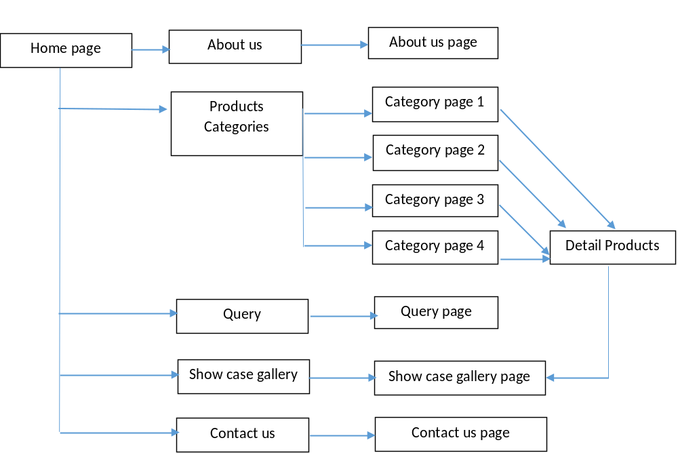

Mock of the website:
1) Homepage:
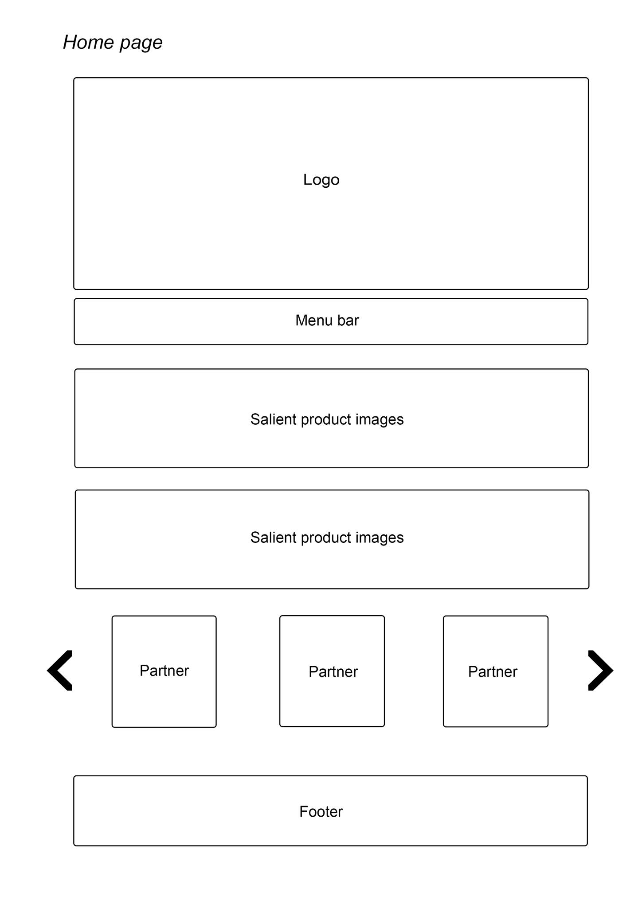

2)About us:

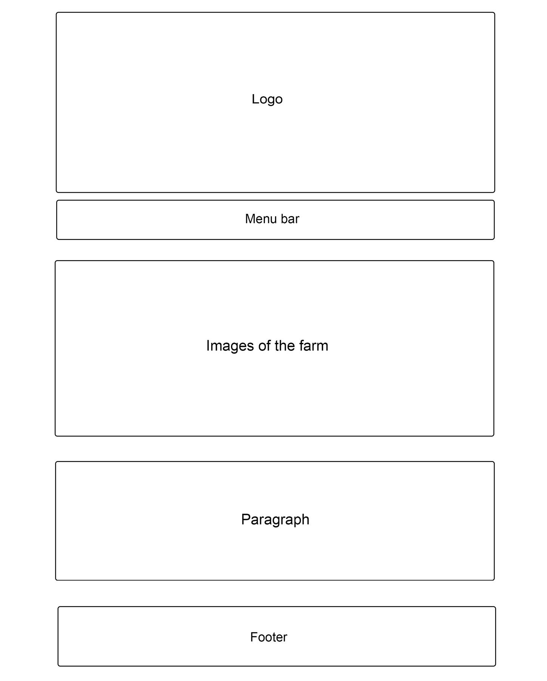

3)Products pages (categories):
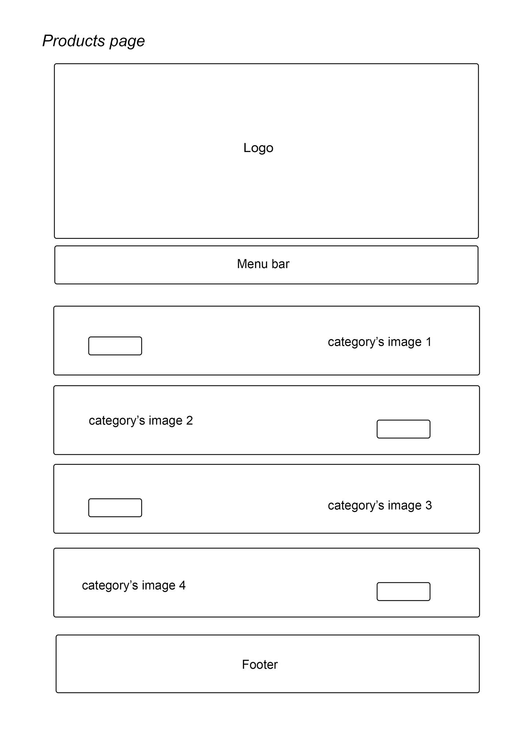

4)Detail products page:

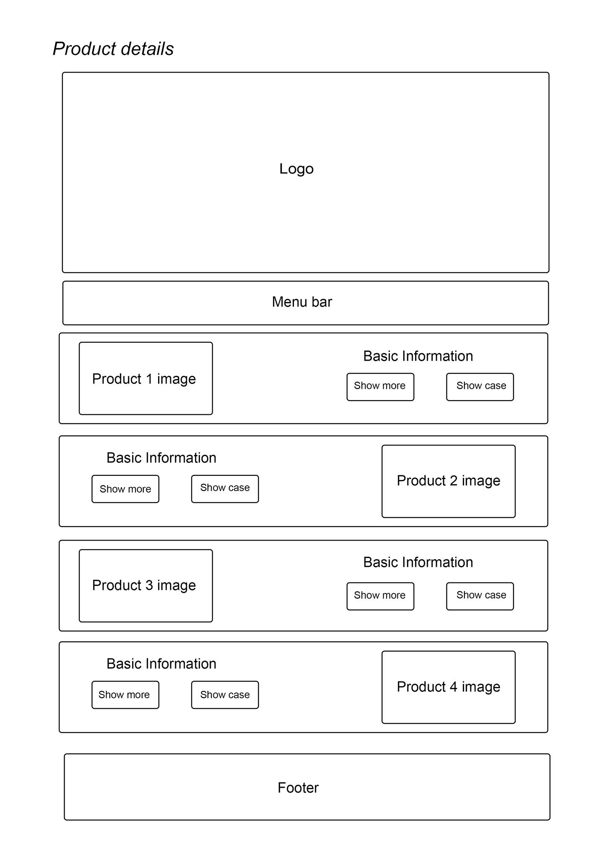

5)Query page:
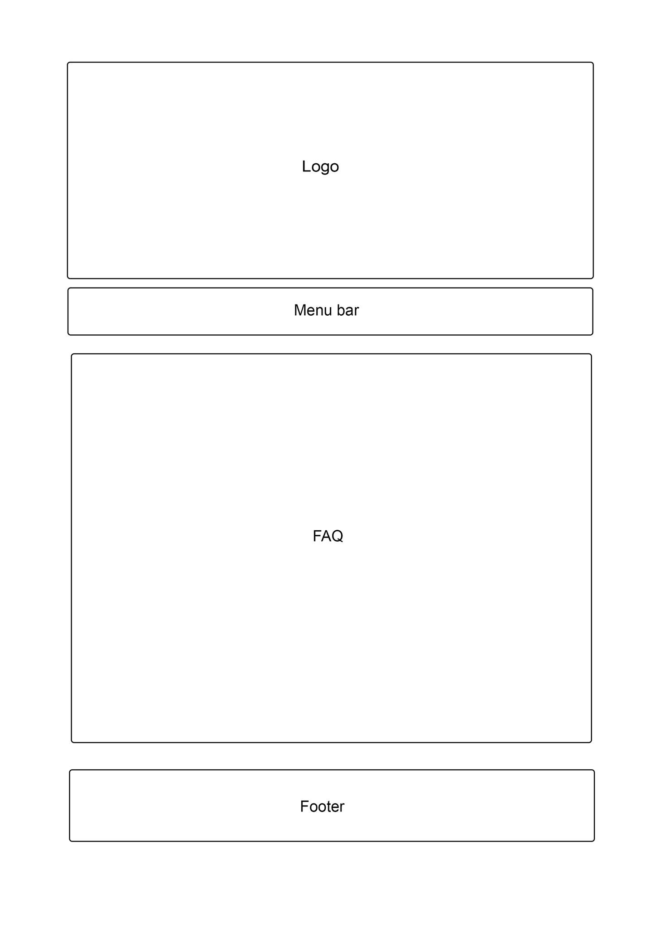

6) Showcase gallery:
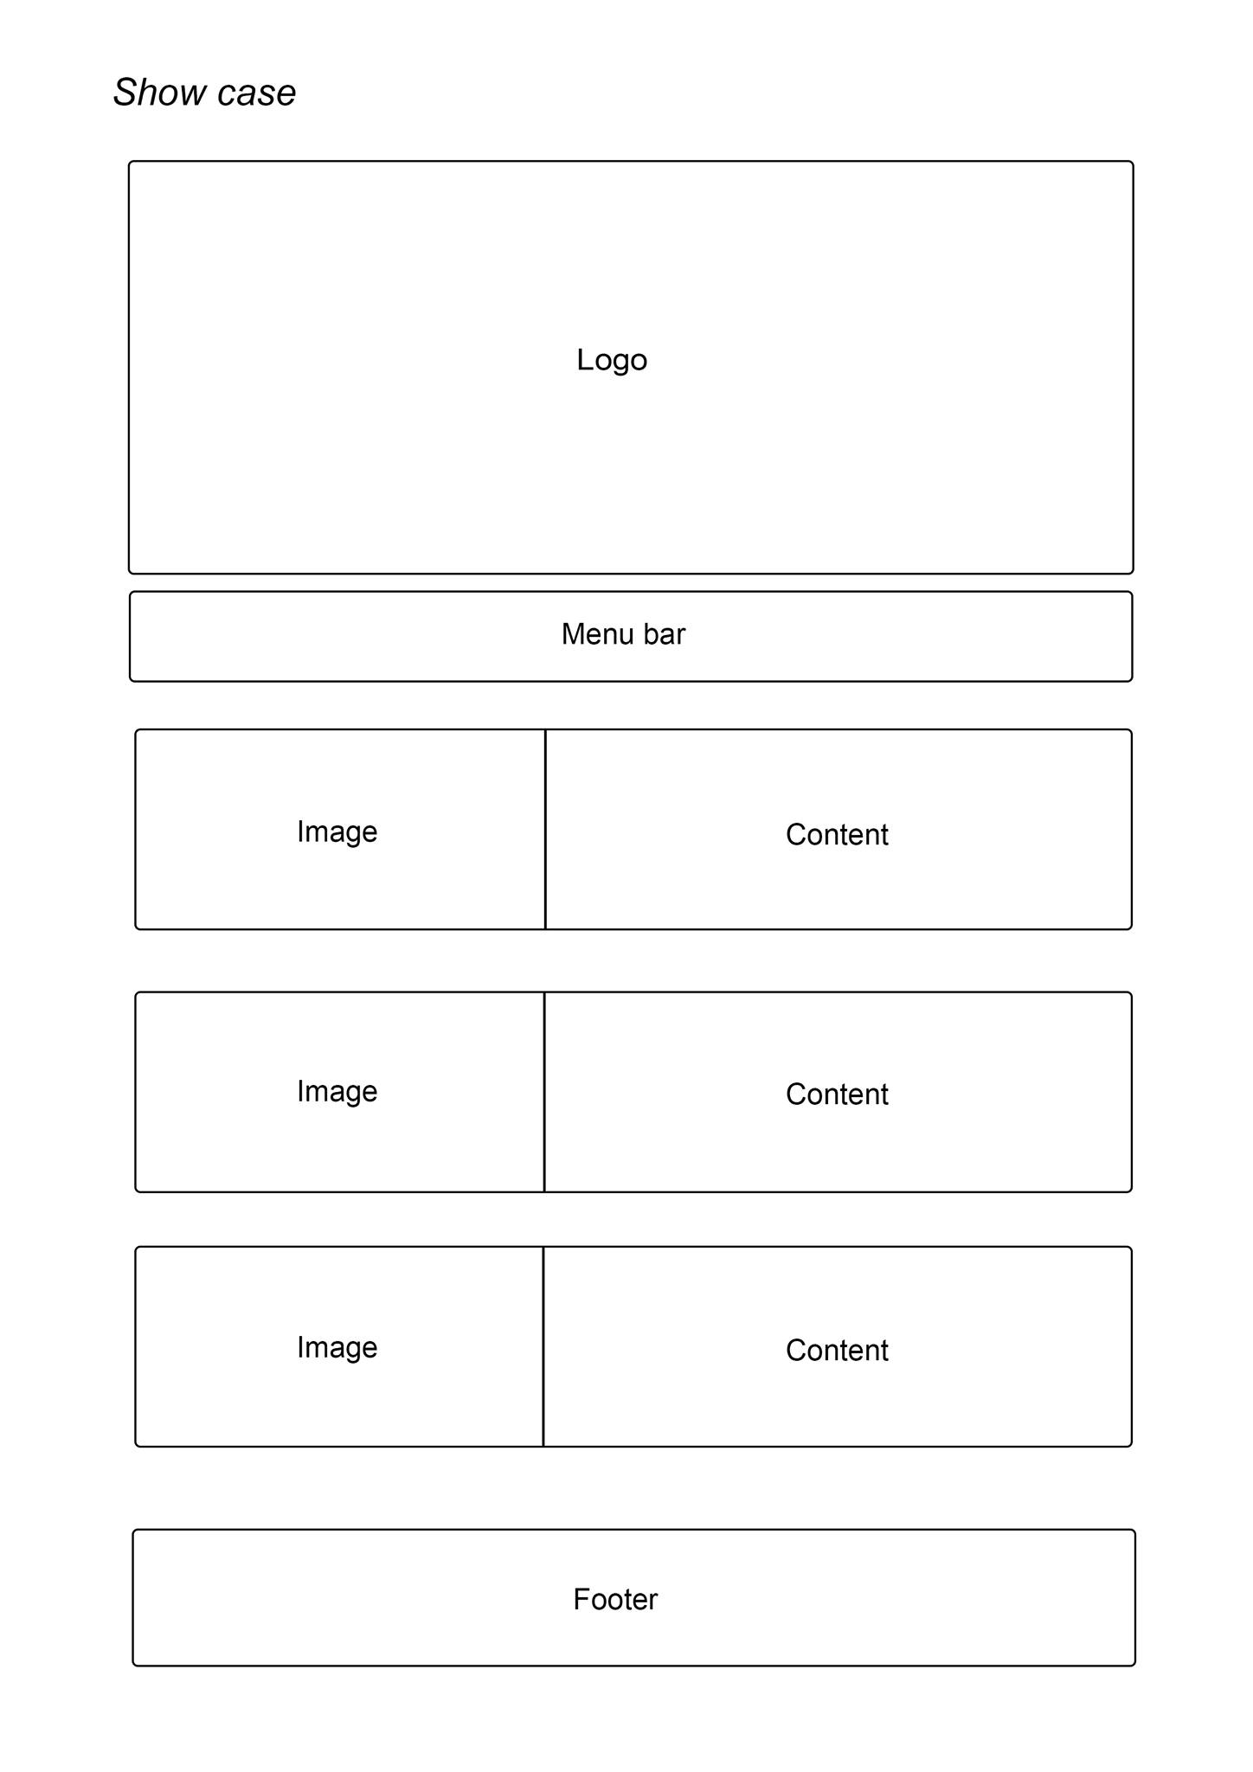

6) Contact us:
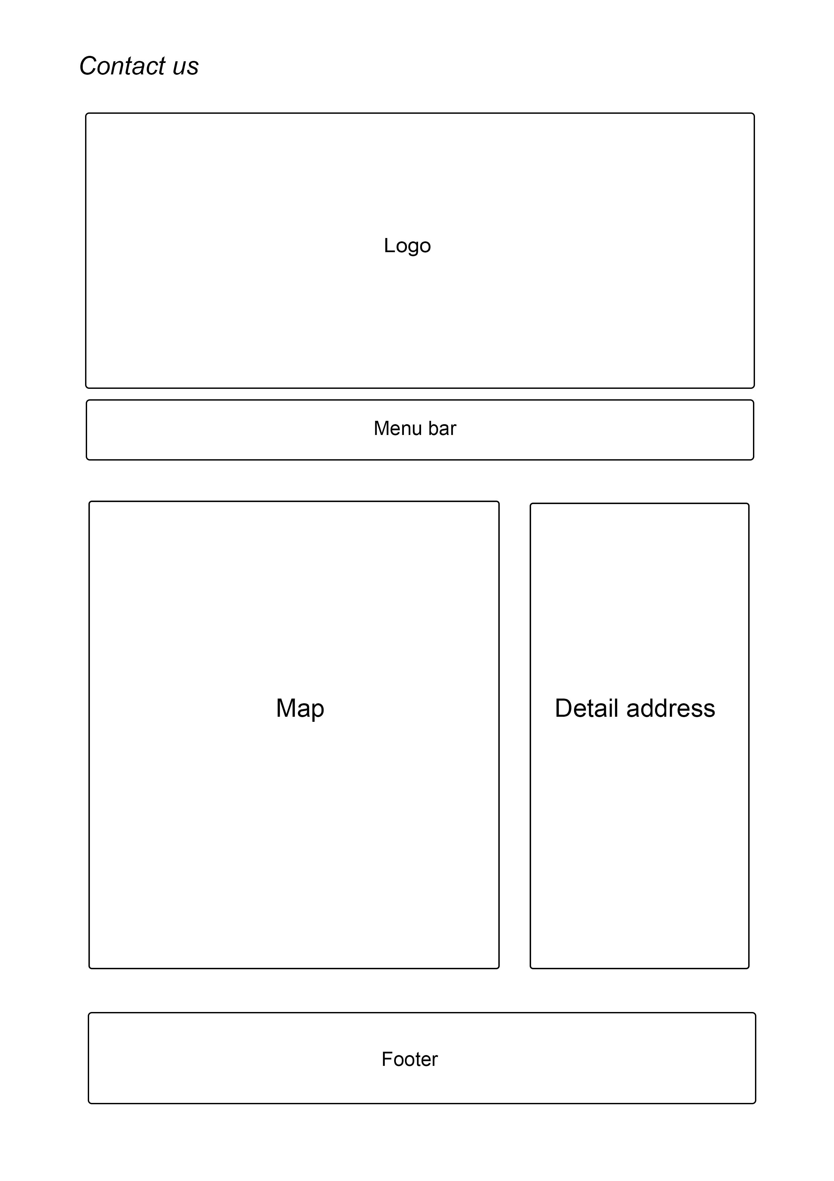

TASK SHEET REVIEW 2
Project Ref.No eP/Advertisement Portal Management System 01 |  | Project Title | Activity Plan Prepared By: | Date of Preparation of Activity Plans”
No. | Task | Project Title | Activity Plan Prepared By: | Actual Start Date | Actual  Days | TeamMate Name | States
1 | Mock of the website | StarOrganic.com | All teammates | 11/05/2017 |  | All teammates
2 | Site map |  |  |  |  | All teammates
3 | Task sheet |  |  |  |  | Dat

Date:
Signature of Instructor:  Dao Ngoc Anh | Signature of Team Leader:  Le Cong Dat

